On our recent Italian vacation. Amidst the beauty of the Riviera ...
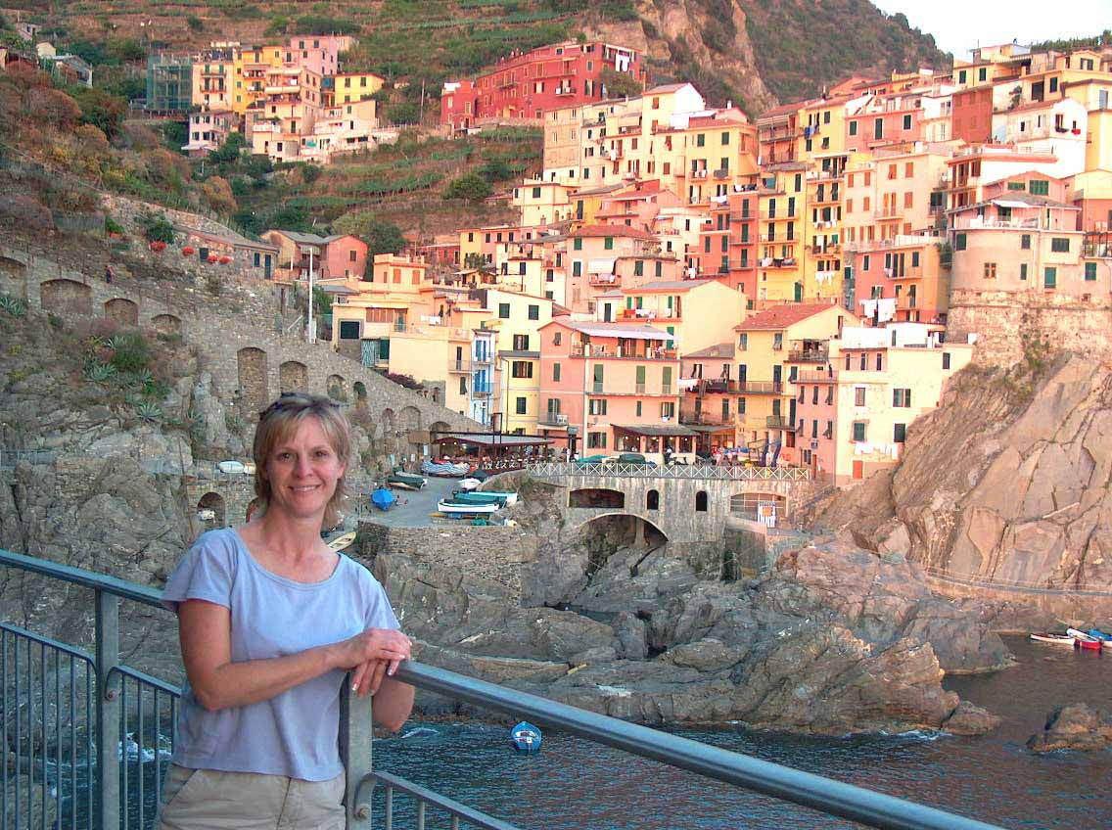

,...And the magic of Michelangelo...
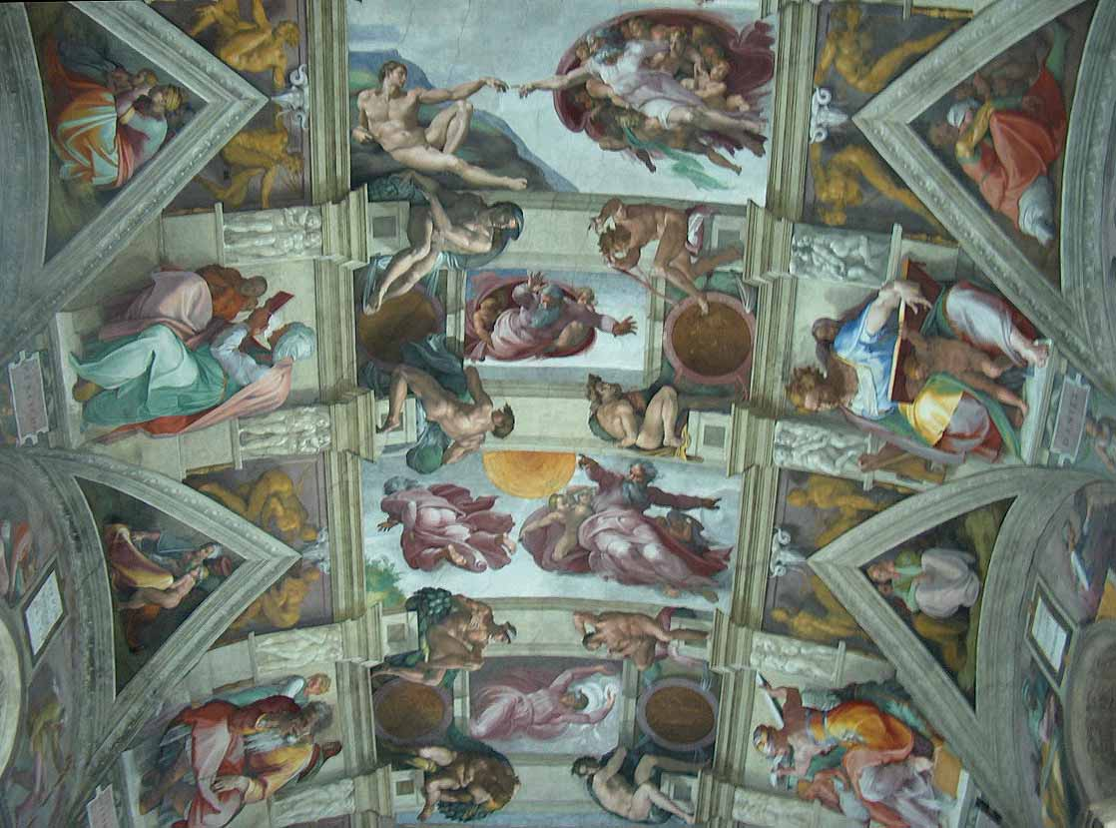

Amongst the ancient ruins ...
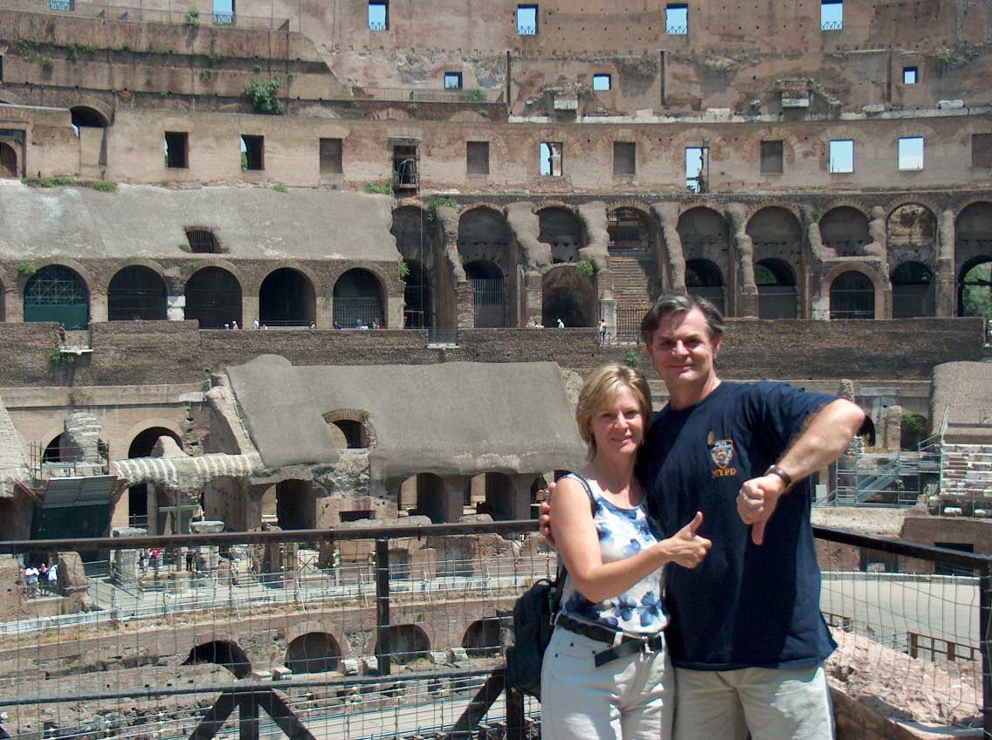

Through the splendor of the Dolomite Alps....
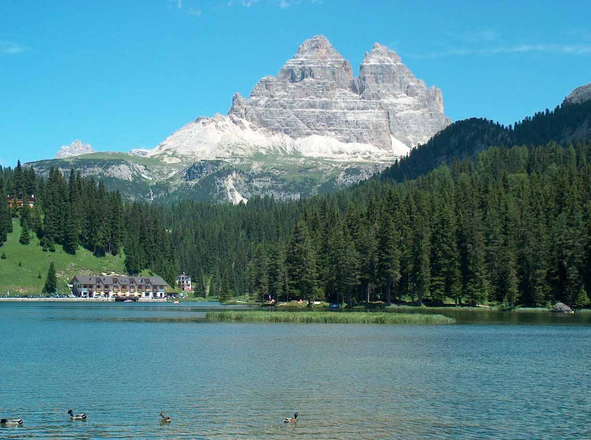

We found this hard working fellow!!!!

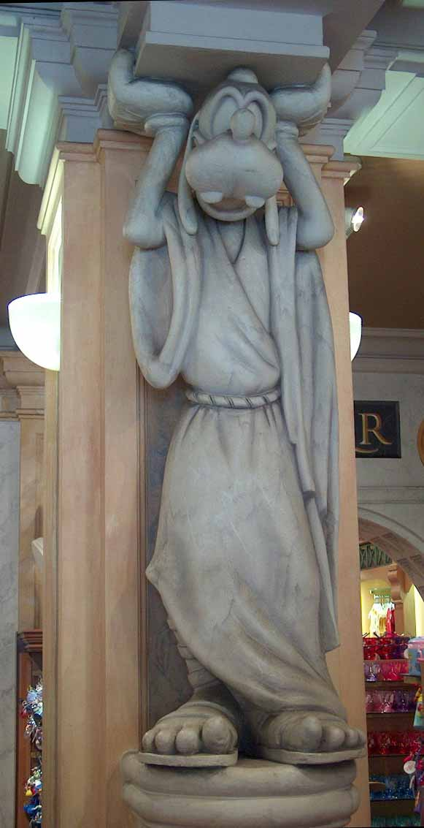

A-Hilt! ... From Jeff & Marie!!

